Lampiran Hasil Printout SPSS 22
Case Processing Summary
 | Cases
 | Valid |  | Missing |  | Total
 | N | Percent | N | Percent | N | Percent
SDA  SDA + GLU | 16  16 | 100.0%  100.0% | 0  0 | 0.0%  0.0% | 16  16 | 100.0%  100.0%

Descriptives
 |  | Statistic | Std. Error
SDA | Mean | 142.25 | 4.592
 | 95% Confidence Interval for Lower Bound Mean Upper Bound | 132.46  152.04
 | 5% Trimmed Mean | 141.67
 | Median | 139.50
 | Variance | 337.400
 | Std. Deviation | 18.368
 | Minimum | 120
 | Maximum | 175
 | Range | 55
 | Interquartile Range | 37
 | Skewness | .344 | .564
 | Kurtosis | -1.152 | 1.091
SDA + GLU | Mean | 204.94 | 11.827
 | 95% Confidence Interval for Lower Bound  Mean Upper Bound | 179.73  230.15
 | 5% Trimmed Mean | 201.99
 | Median | 191.50
 | Variance | 2238.196
 | Std. Deviation | 47.310
 | Minimum | 151
 | Maximum | 312
 | Range | 161
 | Interquartile Range | 51
 | Skewness | 1.208 | .564
 | Kurtosis | .580 | 1.091

Lampiran Hasil Uji Normalitas Sebelum Transformed
Tests of Normality
 | Kolmogorov-Smirnovª |  |  | Shapiro-Wilk
 | Statistic | df | Sig. | Statistic | df | Sig.
SDA  SDA + GLU | .132  .207 | 16  16 | .200*  .064 | .922  .862 | 16  16 | .179  .020
*. This is a lower bound of the true significance.
a. Lilliefors Significance Correction
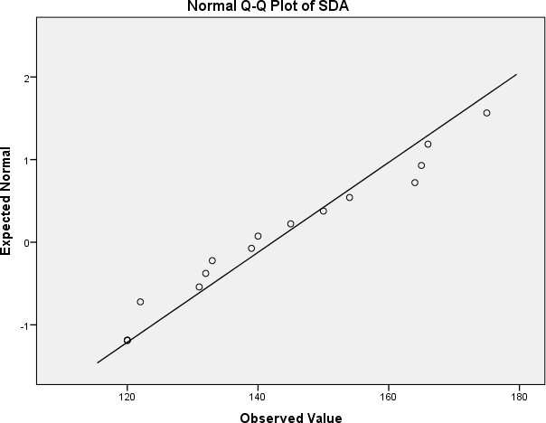
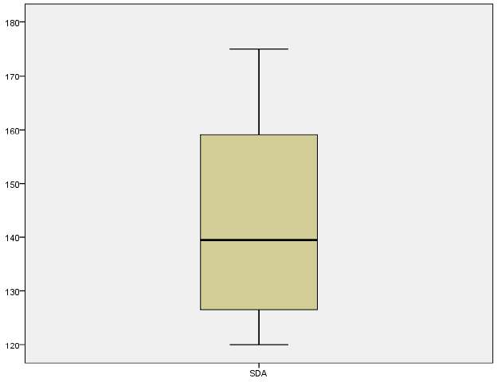

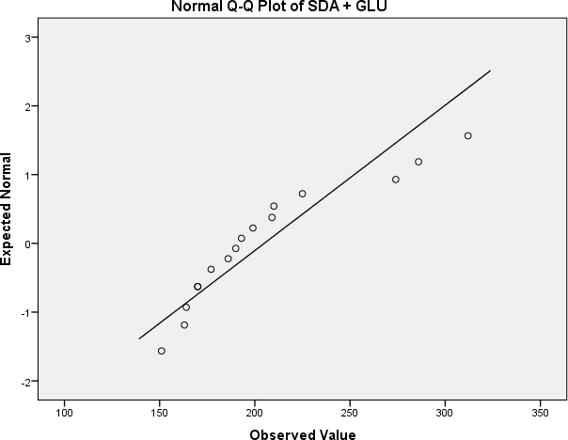

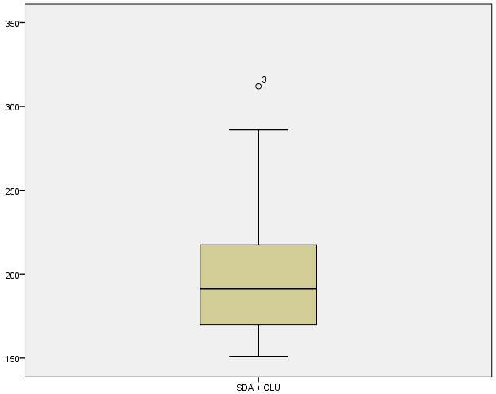

Lampiran Hasil Uji Normalitas Setelah Transformed
Tests of Normality
 | Kolmogorov-Smirnovª |  |  | Shapiro-Wilk
 | Statistic | df | Sig. | Statistic | df | Sig.
SDA  SDAdanGluk osa | .132  .163 | 16  16 | .200*  .200* | .922  .911 | 16  16 | .179  .122
*. This is a lower bound of the true significance.
a. Lilliefors Significance Correction

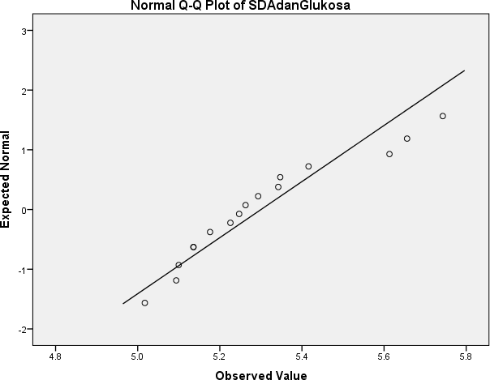

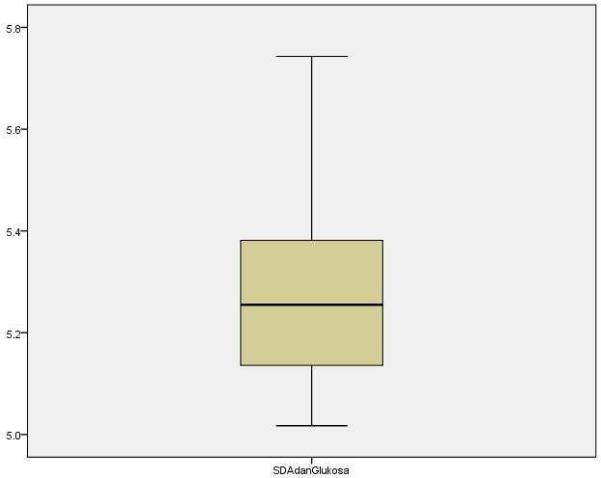

Lampiran Hasil Uji T Berpasangan

Paired Samples Statistics
 | Mean | N | Std. Deviation | Std. Error Mean
Pair 1 SDA | 142.25 | 16 | 18.368 | 4.592
SDAdanGluk  osa | 5.3003 | 16 | .21293 | .05323

Paired Samples Correlations
 | N | Correlation | Sig.
Pair 1 SDA & SDAdanGlukosa | 16 | .321 | .226

Paired Samples Test
 | Paired Differences |  |  |  |  | t | df | Sig. (2-  tailed)
 | Mean | Std.  Deviation | Std. Error Mean | 95% Confidence Interval of the Difference
 |  |  |  | Lower | Upper
Pair 1 SDA -  SDAdan Glukosa | 136.94968 | 18.30130 | 4.57533 | 127.19761 | 146.70176 | 29.932 | 15 | .000

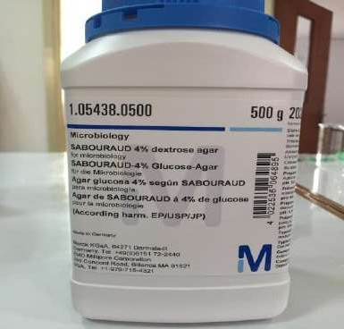
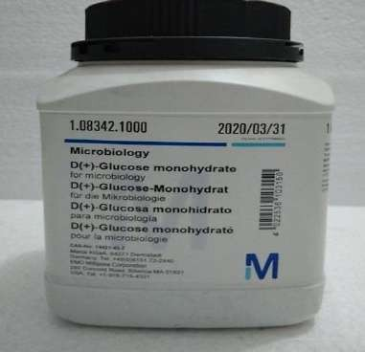
Lampiran Foto Alat dan Bahan
Media Sabouraud Dextrose Agar Glucose For Microbiology
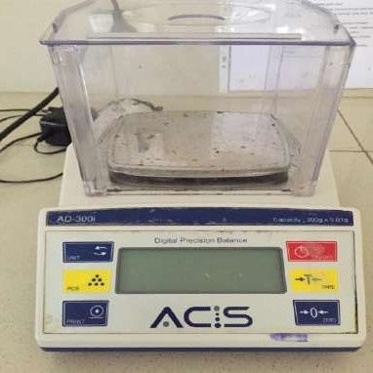
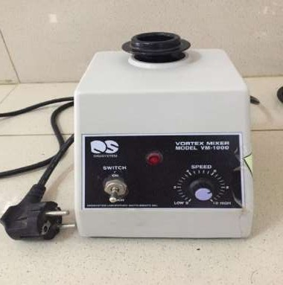
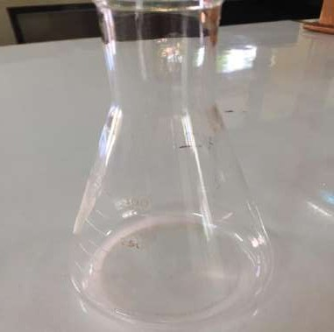
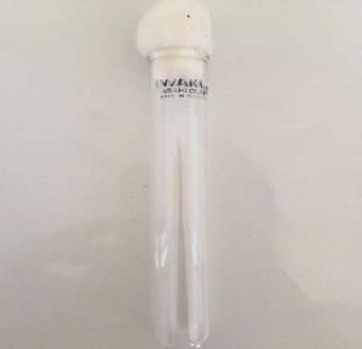
Neraca Analitik Vortex
Labu Erlenmeyer Tabung Reaksi

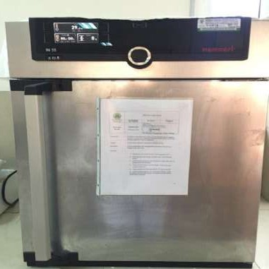
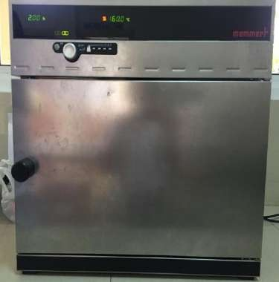
Inkubator Dry Heat Oven
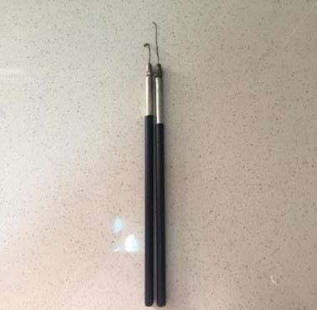
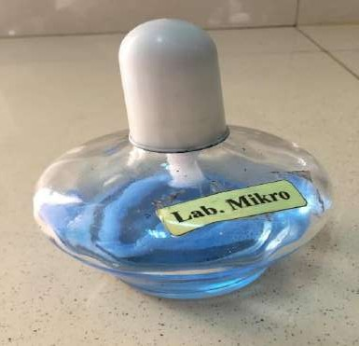
Ose Bulat dan Ose Bengkok Lampu Spritus (Bunsen)

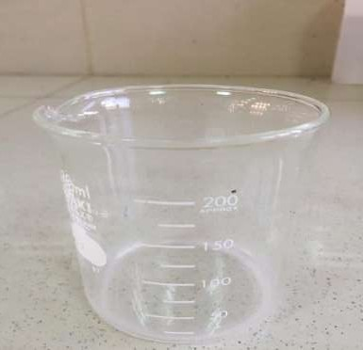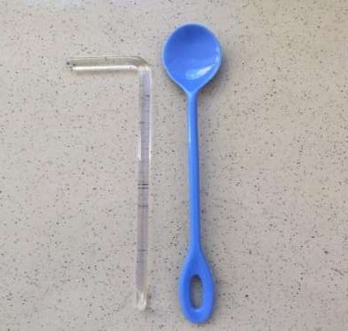
Beeker Glass Tangkai Bengkok dan Sendok Reagen
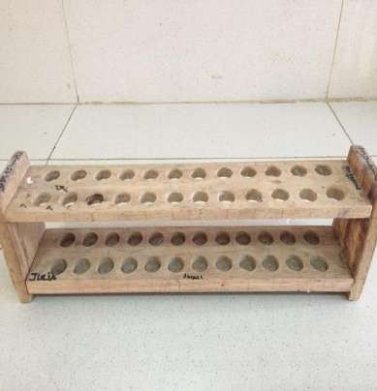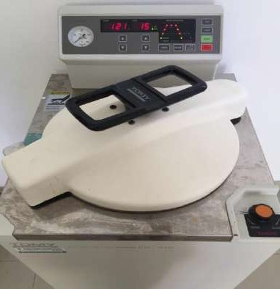

Rak Tabung Reaksi Autoclave

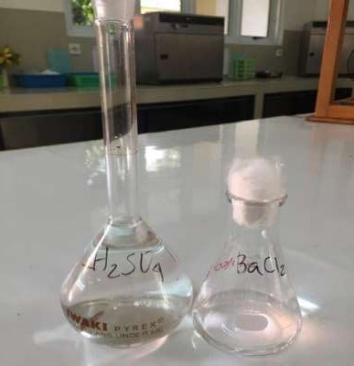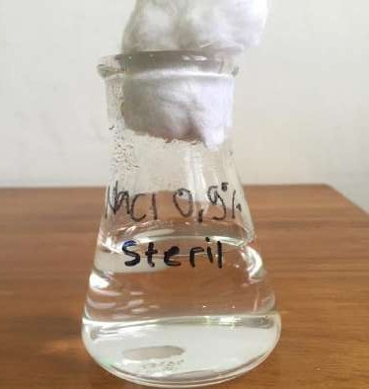
Larutan H₂SO₄ dan BaCl₂ Larutan NaCl 0,9% Steril

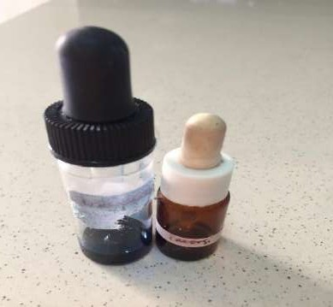
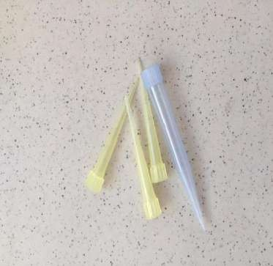
Larutan LPCB dan Oil Imersi Yellow dan Blue Tip

Lampiran Foto Peneslitian

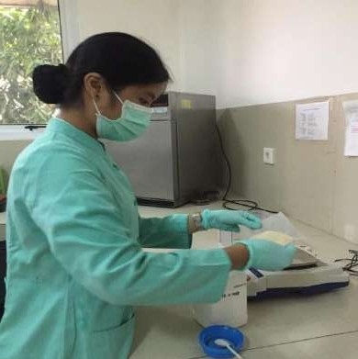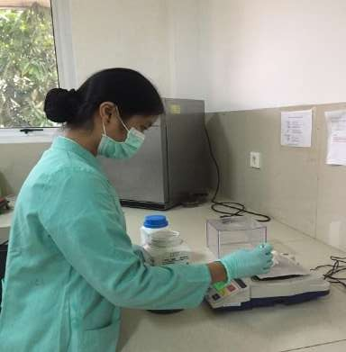

Penimbangan Media SDA Penimbangan Glucosa Microbiology
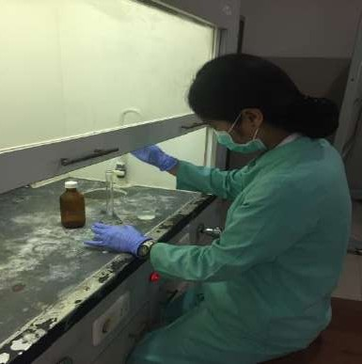
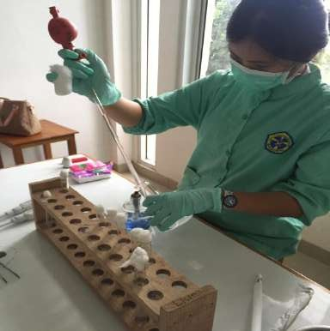
Pembuatan McFarland No 0.5 Pembuatan Inokulum
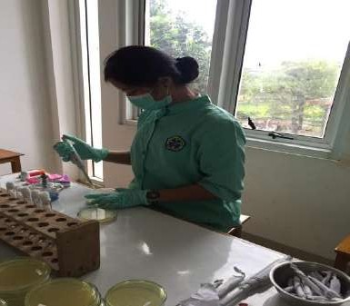
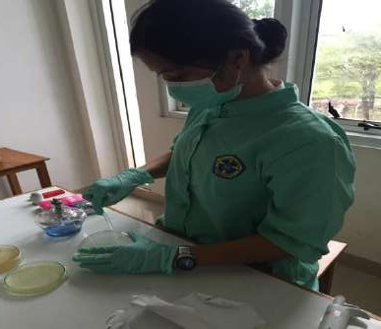
Penanaman Inokulum Pada Media Penyebaran Inokulum

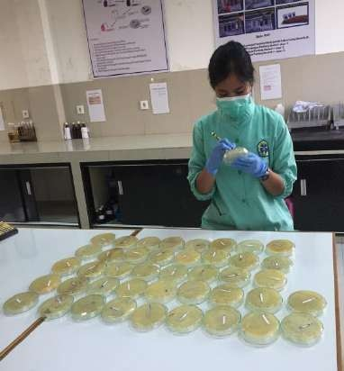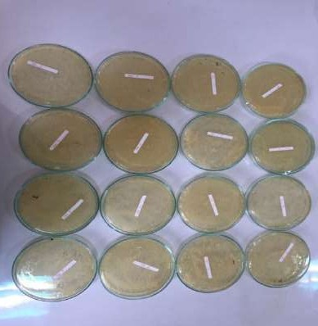

Penghitungan Jumlah Koloni Koloni Pada MediaSDA Glukosa 3 gr
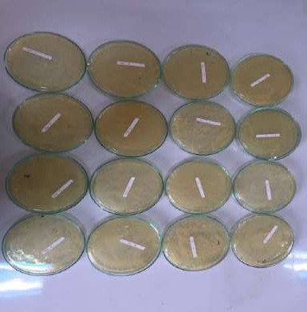
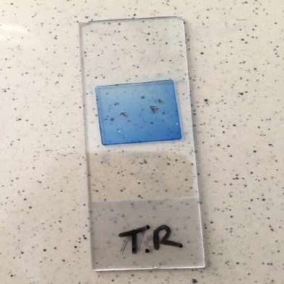
Koloni Pada Media SDA Preparat Trichophyton rubrum
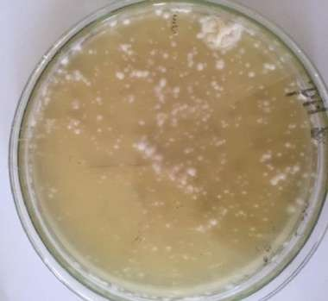
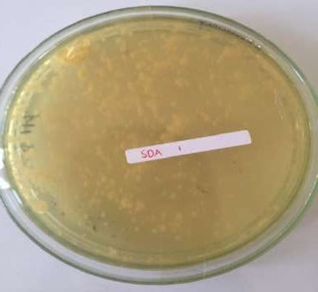

Koloni Pada Media SDA (A) Koloni Pada Media SDA (B)

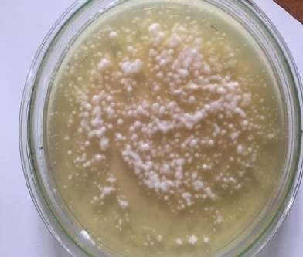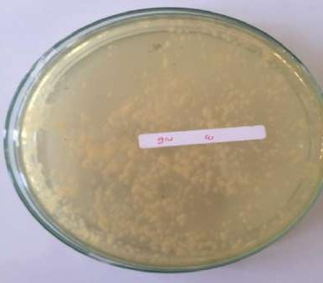
Koloni Pada Media SDA Glukosa(A) Koloni Pada Media SDA Glukosa(B)

